**Journal:** Journal of Fish Biology? PCI?

**Title:** Population specific response of whitefish embryos exposed to contrasted temperatures

**Authors:** Taylor STEWART4/Charles BRUN1, Mikko MAKINEN2, Chloé GOULON1, Jean GUILLARD1, Martin DAUFRESNE3, Juha KARJALAINEN2, Emilien LASNE5

Corresponding author: [emilien.lasne@inrae.fr](mailto:emilien.lasne@inra.fr)

*corresponding author

**Abstract:**

**Introduction:**

Climat

Dahlke et al. 2020

Whitefish *Coregonus lavaretus* is a stenothermal, cold water adapted salmonid species. It is widely distributed in Eurasia from 45 to 70°N. In northern areas, it lives in shallow oligotrophic lakes or rivers, and has both anadromous and resident populations whereas in southern locations, it lives in deep lake that provide cold refugia in deep layers. Whitefish is highly polymorphic and may be present in the same lake under various morphs adapted to living, feeding and spawning in the various lacustrine habitats i.e. littoral, profundal and pelagic. Reproduction occurs in autumn or winter when water temperature decreases around 7°C that triggers ovulation and spawning (Anneville *et al.*, 2013). Embryos then require cold temperature less than 7°C for optimal development over which mortality or malformation occurrence increases (Cingi *et al.*, 2010). Embryonic development of whitefish is clearly a thermal bottleneck (Dahlke *et al.*, 2020). Although there is now consensus that some whitefish populations are at risk in a warming climate (Trippel *et al.*, 1991; Graham & Harrod, 2009; Cingi *et al.*, 2010; Karjalainen *et al.*, 2015), among populations variation in thermal response needs to be assessed.

In this study, we explore the response of whitefish embryos from a Fennoscandian lake and three perialpine lakes to increased temperature. Using a common garden approach, reaction norms for survival and incubation timing are computed, and genetic additive variance is analysed to evaluate if populations from different lakes show contrasted response in term of survival rates, incubation period. According to the local adaptation theory, we predict better performance of embryos from populations of southern lakes to high temperature as temperature in those latter is naturally higher.

**Material and methods:**

*Study populations*

Lake Southern Konnevesi (Finlande)

Lake Southern Konnevesi (hereafter referred as Lake Konnevesi) is a large shallow lake

120km² surface area and 57m deep….

Lake Constance (Germany, Switzerland, Austria)

Lake Geneva (France, Switzerland)

Lake Bourget (France)

Fertilization and experiments took place in in Konnevesi research Station, Finland, for Lake Southern Konnevesi whitefish population and at the INRAE facilities in Thonon-les-Bains, France, for perialpine lakes (Constance, Geneva and Bourget).

*Gametes collection*

The experiment was performed during winter 2018-2019. Genitors were caught by gill-netting during spawning period (December in perialpine lakes, November in Finland). Nets were set at dusk and recovered at dawn. Fish were checked for ripeness and immediately stored in water tanks on boats and transported to local facilities. They were anaesthetized using clove oil (DILUTION?) and measured (total length (nearest mm) and weighted (neared g); see table X. Scales were sampled for age determination for gametes stripping, and gametes were stripped. Constance and Lake Bourget gametes were stored at X°C and immediately transported to the INRAE facilities in Thonon les Bains.

For each of the females, a sub-sample of unfertilized eggs were collected for dry mass measurements. Ten separate eggs were collected from each of them as well as a batch of 30 eggs. The samples were placed in an oven-dryed at 60°C for 4 days and weighted (± 0.1 mg).

*Crossing design and artificial fertilizations*

Standard water was used for the entire experiment according to the OECD (1992) guidelines both for fertilization and for incubation.

We fertilized fish by creating 3 blocks of 3 dams x 4 sires according to a full factorial design for Lake Geneva and Lake Bourget and Lake Constance pelagic populations, and 1 block for Lake Constance littoral morph because of low spawners catches.

Eggs were kept for 24h (?) in petri dishes at X°C, in the dark.

The day after fertilization, all egg families were observed to roughly verify the fertilization rate of each family. This excludes families that appear to have the least concluding results (no membrane detachment). Ultimately, 36 families were obtained for each of the populations from Lake Geneva, Bourget and Pelagic Constance, and 12 families for Coastal Constance (due to the lack of spawners).

|  |  |  |  |  |  |
| --- | --- | --- | --- | --- | --- |
| **population** | **Morph** | **Block 1** | **Block 2** | **Block 3** | **Nb families** |
| **L. Konnevesi** |  | 4 sires x 3 dams | 3x2 | 3x2 | 24 |
| **L. Constance** | pelagic | 4x3 | 4x3 | 4x3 | 36 |
| **L. Constance** | littoral | 4x3 |  |  | 12 |
| **L. Geneva** | littoral | 4x3 | 4x3 | 4x3 | 36 |
| **L. Bourget** | littoral | 4x3 | 4x3 | 4x3 | 36 |

*Treatment*

resulting in each family having 36 eggs incubating at 7°C and 36 others at 9°C in two temperature-controlled chambers. In each room, the 36 individuals per family were distributed in three different 24-well plates (Greiner bio-one brand), in order to separate the treatments from a potential plaque effect.

The eggs were then placed individually with a pipette at the bottom of the wells of the plates previously filled with 2 ml of reconstituted water. For every experimental populations, 360 plates were constituted for the experiment for a total of 8640 eggs in incubation.

The embryos were placed in two thermo-regulated chambers, one at 7°C to mimic optimal temperature conditions for the embryonic development of whitefish, the other at 9°C to mimic temperatures in the upper part of the tolerance range (ref).

Temperatures were monitored and measured by probes (three per chamber) recording the temperature every hour (Tinytag TG-4100 recorder in Thonon-les Binas Facilities and X in Konnevesi Research Station). In the coldest chamber, the average temperature was 7.43°C (standard deviation of 0.18°C) and in the other chamber, the temperature was 9.29°C (standard deviation of 0.02°C). To ensure a certain homogeneity of temperatures and darkness, the samples were placed in cabinets covered with opaque black tarps.

*Life-history traits*

Survival at hatching

In order to rule out the fertilization rate that could be quite high depending on families, survival to hatching was assessed from the eyed stage. Eggs were checked at 180 ADD and only eyed eggs were kept in the following steps, including survival evaluation. Survival rate has been calculated by dividing the number of hatched individuals by the number of individuals that have reached the eye stage.

Incubation time

To characterize the incubation time, it is necessary to speak in terms of degree-days, which corresponds to the sum of the average daily temperatures of the incubation environment. Hatching for whitefish can start from 330 ADD (ref), which allows to anticipate and start plate monitoring. From the first hatched individual, monitoring of the plates is carried out daily, and the date of all newly hatched individuals is recorded.

*Statistical analyses*

Statistical analysis were performed using RStudio (Version 1.0.44 - © 2009-2016 RStudio). In order to analyze the different response variables in this study, generalized linear mixed-effect models from the "lme4" package were used to test the influence of fixed or random variables on these response variables. Parameters such as temperature, population, egg mass per female, size, weight/age of spawners were used as a fixed effect, while the variables "sex", "family", "block" and "plate" were treated as a random effect.

Narrow-sense heritability h2 was calculated for survival at hatching and incubation period as h2=σa²/σp², where σa, the genetic additive variance, is calculated as 4 x (σsires)², and σp, the total phenotypic variance, is calculated as the sum of the residual and additive variance (Lynch & Walsh, 1998).

**Results**

Survival at hatching

Survival at hatching was significantly higher at 7°C than 9°C (on average, X% decreased survival, populations considered together).

Post-hoc tests revealed that survival was/was not different between population in the warm treatment but not in the cold one.

Although no effect of population alone on survival was detected, interestingly, significant population x temperature interaction did, meaning that temperature had a different effect depending on populations. Survival loss was the lower for the Lake Bourget population, and the higher for Lake Constance littoral population.

Incubation period

Globally, time to hatch did was not clearly correlated to neither temperature nor population. We, however, detected a significant interaction between temperature and population suggestion contrasted response to temperature. Post-hoc tests showed that development times to hatching vary between populations depending on the incubation temperature. Indeed, while embryos from Lac de Bourget do not show any difference in incubation time between 7° and 9°C (see Table 1), the other three populations have their development times reduced at high temperatures.

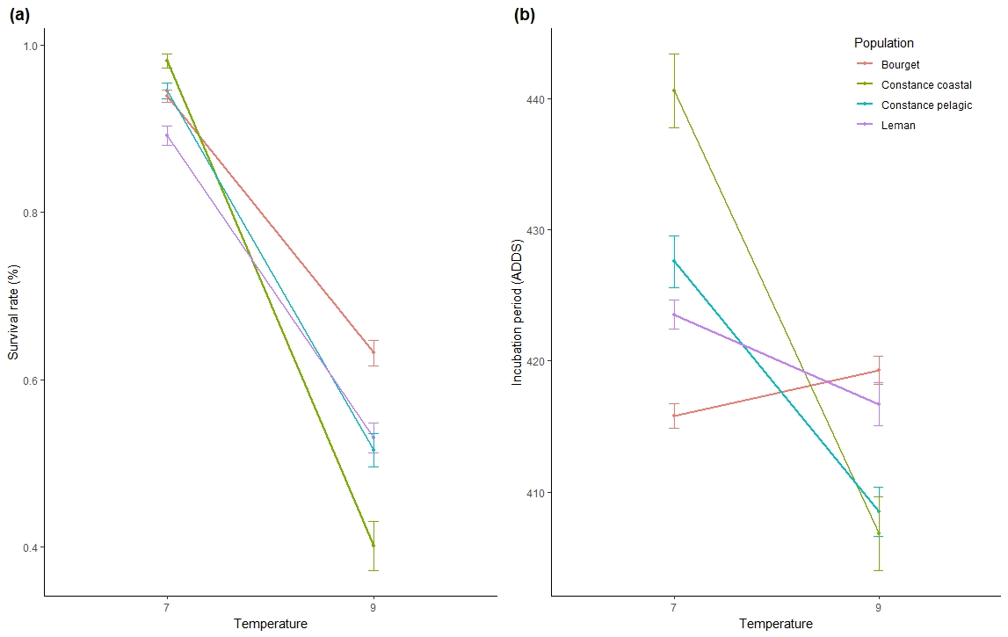

Table x:

|  |  |  |  |  |  |  |
| --- | --- | --- | --- | --- | --- | --- |
|  | Survival | | | Incubation period | | |
|  | Chisq | Df | (>Chisq) | Chisq | Df | (>Chisq) |
| (Intercept) | 40.8068 | 1 | **<0.0001** | 0,7547 | 1 | 0,3849 |
| Temperature | 125.7569 | 1 | **<0.0001** | 1,8852 | 1 | 0,1697 |
| Population | 3.4509 | 3 | 0,3272 | 4,2899 | 3 | 0,2318 |
| Temperature:population | 29.5514 | 3 | **<0,0001** | 47,9346 | 3 | **<0,0001** |

Table x:

|  |  |  |
| --- | --- | --- |
|  | diff | p adj |
| Bourget () | 3,49 | 0,471 |
| Constance (littoral) | -33,78 | <0,0001 |
| Constance (pelagic) | -19,42 | <0,0001 |
| Léman () | -6,83 | 0,025 |

Heritability

Table X: Narrow sense heritability (h²), additive genetic variance (σa), and total phenotypic variance (σp) estimates measured for survival and incubation period for the three populations at the two temperature treatments cold (7°C) and warm (9°C).

|  |  |  |  |  |  |  |  |
| --- | --- | --- | --- | --- | --- | --- | --- |
|  |  | Cold |  |  | Warm |  |  |
|  |  | σa | σp | h2 | σa | σp | h2 |
| Survival | Bourget | 0,7044 | 1,6327 | **0,4314** | 0,2007 | 0,6872 | **0,2921** |
|  | Leman | 0 | 0,9530 | **0** | 0,3043 | 0,9824 | **0,3098** |
|  | Constance | 1,25E-09 | 3109,31 | **4,03E-13** | 4,3119 | 1,8231 | **2,3652** |
| Incubation period | Bourget | 309,72 | 876,89 | **0,3532** | 191,89 | 706,45 | **0,2716** |
|  | Leman | 226,710 | 842,76 | **0,2690** | 124,84 | 1156,70 | **0,1079** |
|  | Constance | 2095,64 | 2325,78 | **0,9010** | 587,04 | 1098,67 | **0,5343** |

**Discussion**

*Constant versus fluctuating temperature*

*Constant versus fluctuating light intensity*

**References**

Anneville, O., Beniston, M., Gallina, N., Gillet, C., Jacquet, S. & Lazzarotto, J. 2013. L ’ empreinte du changement climatique sur le Léman. *Arch. des Sci.* **66**: 157–172.

Cingi, S., Keinänen, M. & Vuorinen, P.J. 2010. Elevated water temperature impairs fertilization and embryonic development of whitefish Coregonus lavaretus. *J. Fish Biol.* **76**: 502–521.

Dahlke, F.T., Wohlrab, S., Butzin, M. & Pörtner, H.O. 2020. Thermal bottlenecks in the life cycle define climate vulnerability of fish. *Science* **369**: 65–70.

Graham, C.T. & Harrod, C. 2009. Implications of climate change for the fishes of the British Isles. *J. Fish Biol.* **74**: 1143–1205.

Karjalainen, J., Keskinen, T., Pulkkanen, M. & Marjomäki, T.J. 2015. Climate change alters the egg development dynamics in cold-water adapted coregonids. *Environ. Biol. Fishes* **98**: 979–991.

Lynch, M. & Walsh, B. 1998. *Genetics and analysis of quantitative traits*. Sinauer.

OCDE. 1992. OECD guideline for the testing of chemicals 203 (fish acute toxicity test). Annex 2. http://www.oecd.org/ chemicalsafety/assessmentofchemicals/1948241.pdf.

Trippel, E.A., Eckmann, R. & Hartmann, J. 1991. Potential Effects of Global Warming on Whitefish in Lake Constance, Germany. *Ambio* **20**: 226–231.